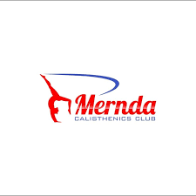

# MERNDA CC COVID

PROCEDURES 2022

Mernda CC



**Members/Parents/Guardians, please read carefully and adhere to the following procedures. These protocols are determined by the Victorian government and are subject to change depending on the ever-growing changes of the pandemic:**

**COVID STANDARD RULES APPLY**

* If you are feeling un-well, with any flu like symptoms such as sore throat, runny nose, cough etc. you must not attend class.
* Please advise us before attending your doctor for a test. You must not return to class until providing us with a Covid-19 clearance.
* Anyone above the age of 12 are required to be Double Vaccinated to enter the training facilities. (Proof will be required to be sighted by a member of the coaching team or committee)
* As you are aware face masks for children over 12 and all adults must be worn on an ongoing basis until otherwise informed.
* Wash hands thoroughly for 20 seconds
* Stand 1.5 mts away

**DROP OFF ZONE**

* Parents are to use the drop off and pick-up zone. Please see the map attached. Parents will not be permitted to stay during class times if they are not double vaccinated or if capacity restriction don’t allow for numbers.
* Access is via the smaller 2nd door that is the entry directly into our room.
* A table will be set on arrival for sign in and out. Parents are encouraged to drop off at the commencement time and pick up at conclusion to avoid loitering at the pavilion.
* As we are sharing with the cricket club, we must be extremely mindful of the numbers we have at the facilities.
* While waiting to sign in please stand 1.5 mts from the person standing next to you.

**QR CODE**

* We have our own Mernda QR code that we would prefer you use on arrival, if you do not have your phone on you at the time, we will have a sign in sheet as well.

**EQUIPMENT**

* All equipment brought into class will need to be sanitised on the way in. Drink bottles, rods, clubs etc.
* All Mernda CC equipment will be sanitised before and after every session.

**SANITISER**

* Please bring a small bottle of sanitiser for your child or yourself during class.

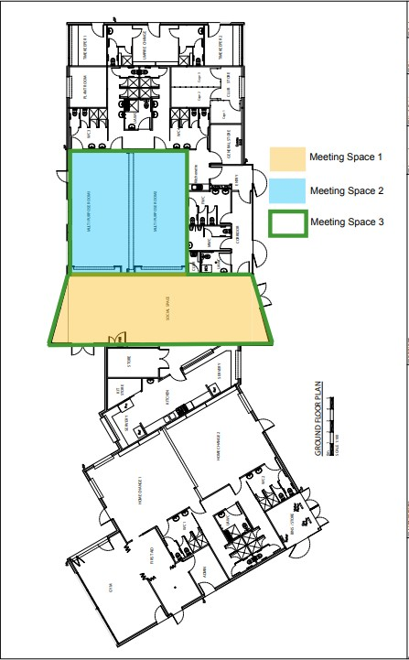

Red Zone – Drop off and pick-up zone for parents

Blue Zone – Calisthenics Covid safe area

Yellow Zone –Parents permitted unless otherwise stated.